UNIX FILESYSTEM

**LAB # 03**



**Spring 2021**

**CSE301L Signals & Systems Lab**

Submitted by: **Ashfaq Ahmad**

Registration No. : **19PWCSE195**

Class Section: **B**

Submitted to:

**Engr. Mian Ibad Ali Shah**

**Department of Computer Systems Engineering**

**University of Engineering and Technology, Peshawar**

1. Create a directory named ics431 under  your home directory. Then create directories named lab1 lab2 lab3 ... inside the ics431 directory. Also create a directory named test inside the directory lab2. Write all the commands.

**Commands:**

1. > mkdir ics431
2. > mkdir lab1 lab2 lab3
3. >s mkdir test

Output:

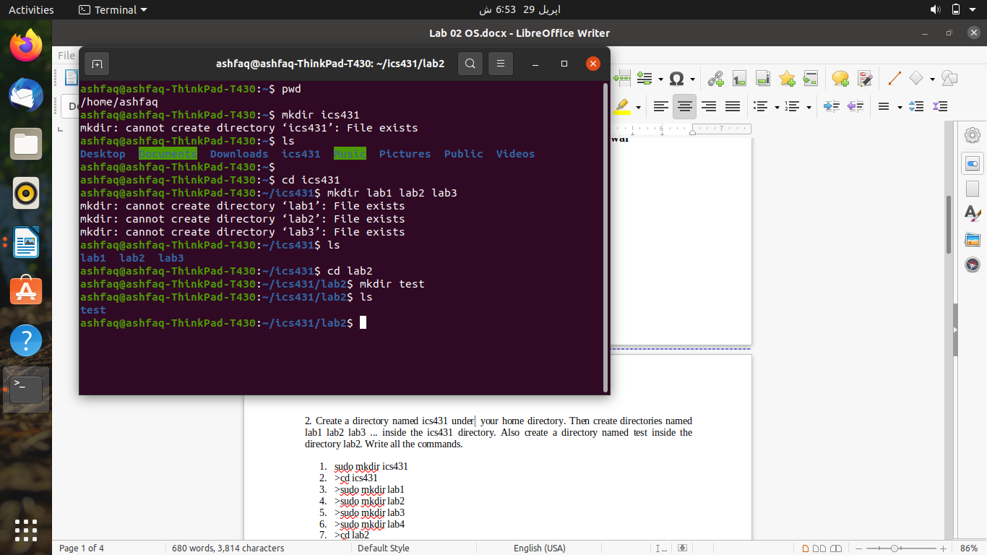

1. Now create a C program file named myprogram.c which displays "C is a programming Language". This file should be in lab2 directoty.

**Command:**

mkdir myprogram.c

OUTPUT:

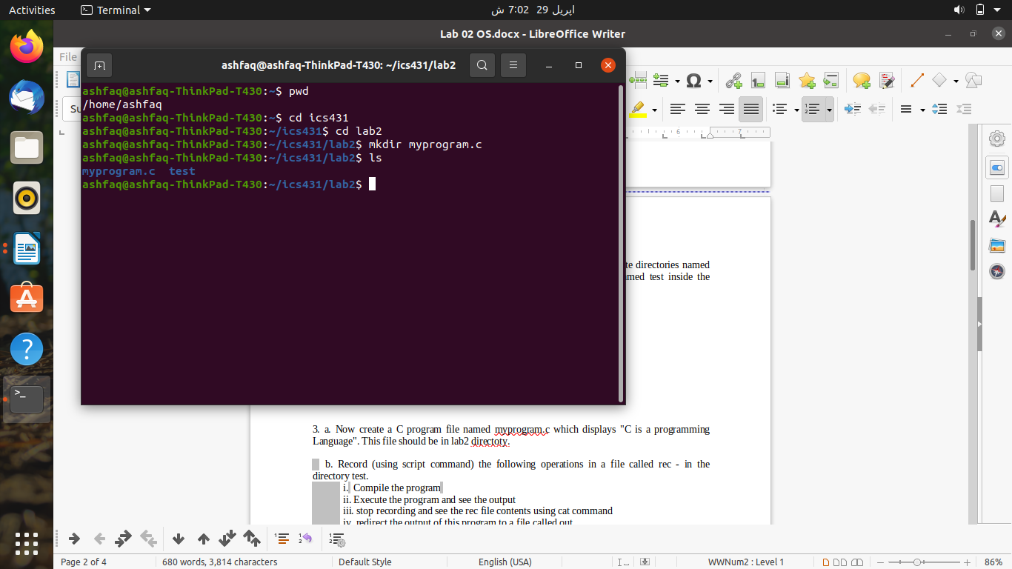

    b. Record (using script command) the following operations in a file called rec - in the directory test.

            i.  Compile the program

            ii. Execute the program and see the output

            iii. stop recording and see the rec file contents using cat command

            iv. redirect the output of this program to a file called out

**Command:**.

The commands I used are follows.

>sudo touch myprogram.c

>sudo nano myprogram.c

After having saved the code in there, I used the following commands.

>sudo script –a lab2/test/rec

>sudo gcc lab2/myprogram.c –o out

>sudo ./out

>exit

>sudo cat lab2/test/rec

            v. What is the content of out and rec. Are They same?

Ans: Assuming that from out, we mean the compiled form of the c program, the answer is no, the two files are not same. One is the binary file containing executable code while other is a text file containing list of commands.

1. Go to the ics431 directory and list all the directory names starting with l. Write the commands.

**Command:**

>ls –d l*

OUTPUT:

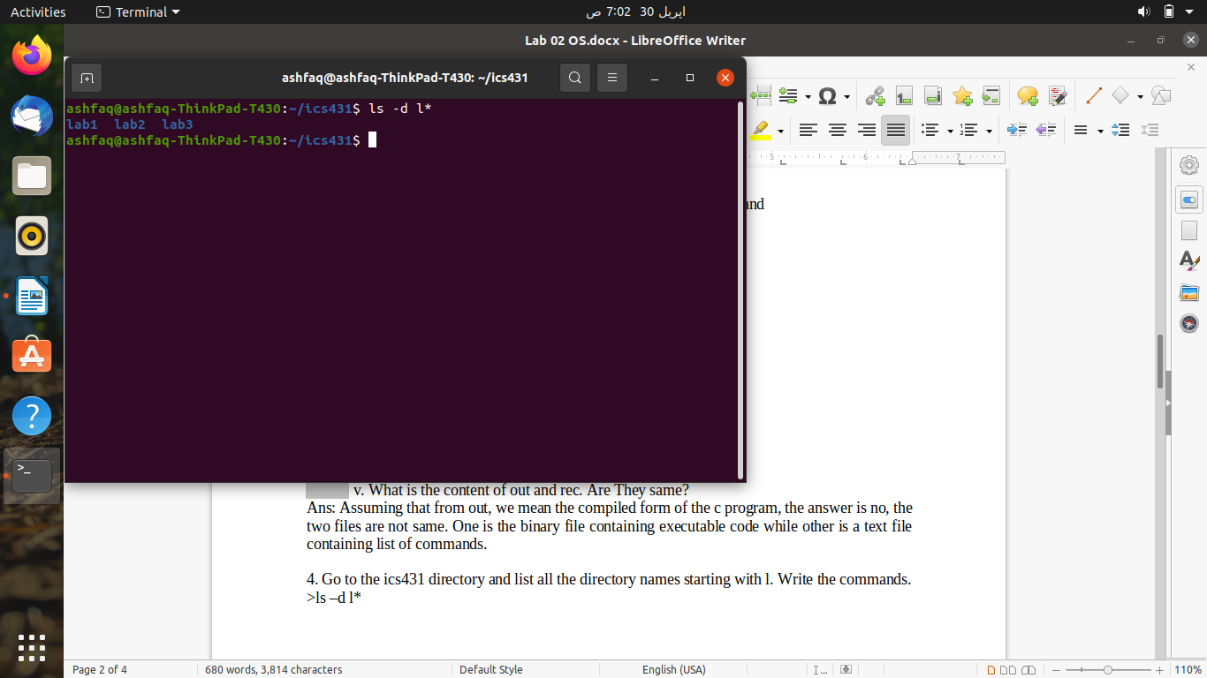

1. From ics431 directory, create a soft link to the test directory in the name linktest.

Commands are given at the end.

Go to linktest directory and display the files. What Files are displayed?

The same file that is in the test directory i.e. rec

From there go to the parent directory. Which parent are you getting? State reasons.

From linktest, If I navigate to ../ (parent) then I end up in ics431 because linktest was a symbolic link placed inside ics431.

**Command:**

>sudo ln –s lab2/test linktest

>cd linktest

>ls

>cd ../

**Output:**

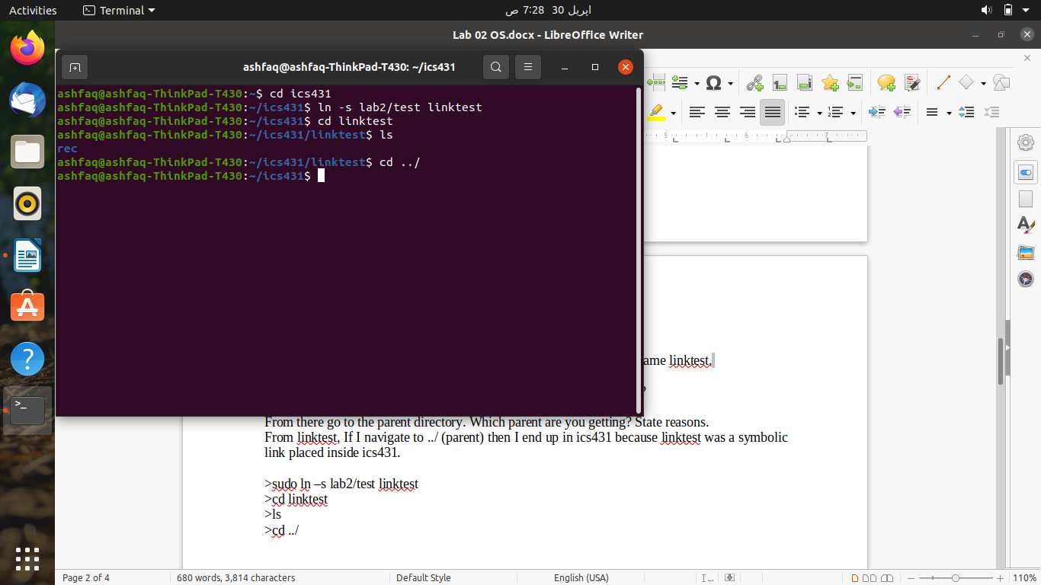

1. Try to open the created file myprogram.c in the notepad of your desktop computer. This can be done by using ftp. Modify the program in notepad to print " Now I like know Unix and windows OS". and execute in the Unix environment (again ftp is needed). Write all the commands to do this**.**

**Command:**

>sudo nano lab2/myprogram.c

After this I got nono editor screen.

After saving it, I ran it using gcc.

>sudo gcc lab2/myprogram.c –o output

>sudo ./output

1. Move the file rec to the directory lab1 and delete the directory test and observe what had happened to linktest. What is it pointing to?

**Command:**

> sudo mv lab2/test/rec lab1/rec

>sudo rm –rf lab2/test

>cd linktest

NOTE: I used –rf since test was a non-empty directory.

After deleting test, linktest was also removed.

1. Record the following:

        a. Go to directory lab1

         b. change the modes of all files to [read exec to owner & group and only execute to others]

Try to delete rec file and observe the o/p. Write the o/p

**Command:**

>cd lab1

>sudo script –a rec

>sudo chmod 551 .

>sudo rm rec

>exit

>cat rec

The rec was successfully deleted (I was inside lab1). And this is why the recording could not be played.

**.**

1. Display a file containing all the full names (in sorted order) of the users currently logged in to the Unix server

Write the commands to do this.

>who

1. Make a copy of the directory ics431 in the same level and name it as CopyOfics431. (All subdirectories and files inside should be copied.)

**Command:**

>sudo cp –r ics431 CopyOfics431

This is the commands. The next are just for confirmation.

>cd CopyOfics431

>ls *

**THE END**